Introduction

OSU Fees Online is a web-based system to improve reporting and accountability while streamlining fee submissions by departments. The site is designed to help create and submit online proposals to add new fees or change/drop existing fees. The Fee Tracking System is currently available for all Internal/External and Course fee submissions.

Getting Started

OSU Fees Online is located at https://fees.oregonstate.edu/. The site allows public access to view or search all existing fees. Authorized users (originators) are permitted to create fee proposals for the purpose of adding, changing, or deleting fees. Any person wishing to become an originator must take and pass an online test before an Administrator will establish their security status. The new originator will also be added to a Fee Book List Serve so they will receive periodic emails from the Administrators.

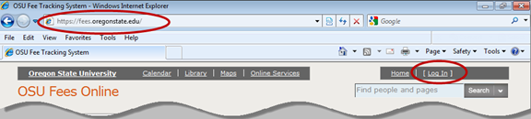

Login Information

Authorized users can log in using their ONID account:

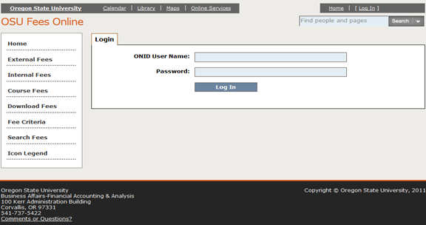

See Computer Help Documents ONID Login Help for any assistance or contact an Administrator.

Once logged in, you can search for fees, download printable fee books in PDF format, submit proposals for Internal, External or Course fees, and review applicable policies (found under Fee Criteria) by clicking on the options in the navigation pane on the left:

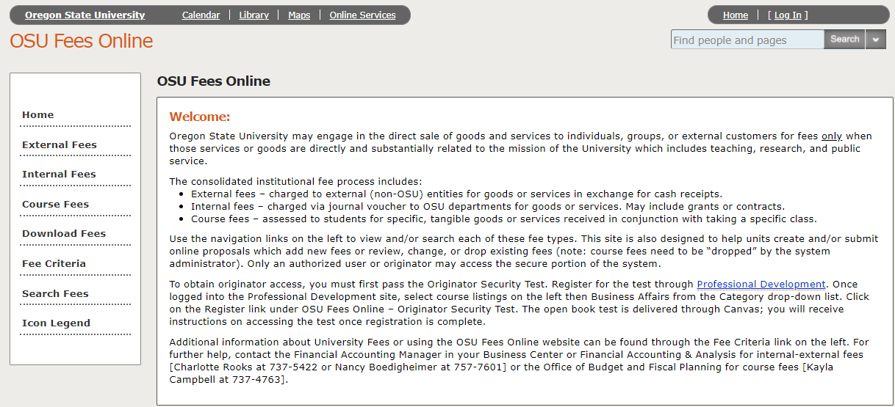

If a university website is used to list the complete fee offerings instead of OSU Fees Online, that website must remain static (unchanged) for the entire fiscal year. The Internal/External (I/E) Fee Committee must give approval in advance before a website is used instead of listing the individual services in the fee book(s). When a website is used to provide the detailed pricing, there should be a fee listed in the fee book with the applicable range for the services provided by the unit.

Any time you add or change a fee, be prepared to present to the I/E Fee Committee the methodology of the fee rate structure and calculation. The Recharge Fee Calculation Form can be found through the FIS List of Exhibits: Most proposals can use FIS-Ex003-10 Recharge Fee Calculation Form as the supporting document for a proposal submission.

Internal/External Fee Proposal Entry Instructions

To submit a new or revised fee or to delete an existing fee, choose the fee type (internal or external) you wish to modify from the navigation pane. You will have access to update fees for only the units authorized to your ONID login. Select the appropriate Unit and Department:

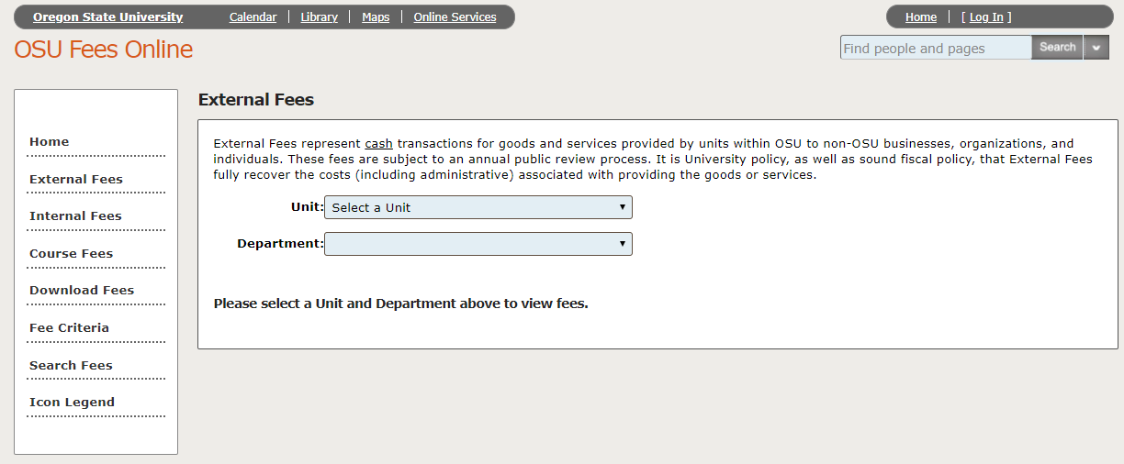

The fees from the first department within the unit selected will populate. To view fees from a different department, select it from the department drop down menu:

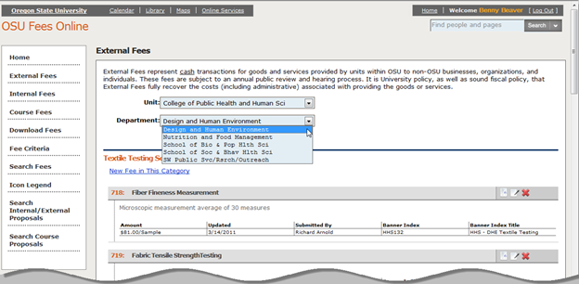

On this screen you can:
- View and review all the current fees for the unit/department selected.
- Add a new fee to the unit/department by selecting the New Fee in This Category link.
- Change an existing fee by clicking the edit fee icon ().
- Remove a fee by clicking the drop fee icon ().

When creating a new fee, your contact information will be updated by the system. You will need to determine if the fee is Internal, External or both. See explanations in OSU FIS 03-150-108 Recharge Activities (Internal & External), if you are unsure about these determinations.

When revising a fee, the current fee information will be populated so you will just need to edit those sections you want to update and add text in the justification field.

The system will take you through a series of steps to submit your fee proposal.

On the Contact screen, verify that your information is correct and make any necessary updates. Click Next to continue:

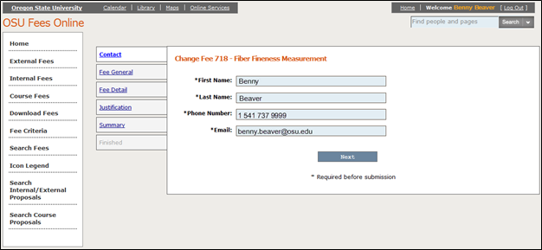

Note: All fields represented by * are required before submitting the request.

On the Fee General screen, add the fee title and description, if necessary, and select the fee type (internal or external). Click Next to continue:

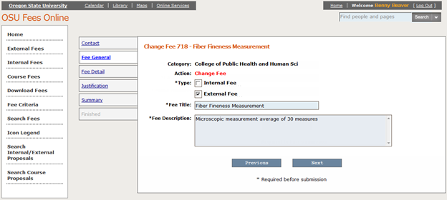

Note: Fee Description is a required field. This is where the test or service is described in enough detail to explain to the customer what they are receiving for the fee they will be charged. If there is something special about the fee application, such as when variable fee amounts are applied, these should be explained here.

On the Fee Detail screen, select the fee amount type (fixed or variable dollar amount) then enter the fee amount(s), the fee unit/condition, the Banner index, and the activity code, if desired. Click Next to continue.

Fixed Dollar Amount:

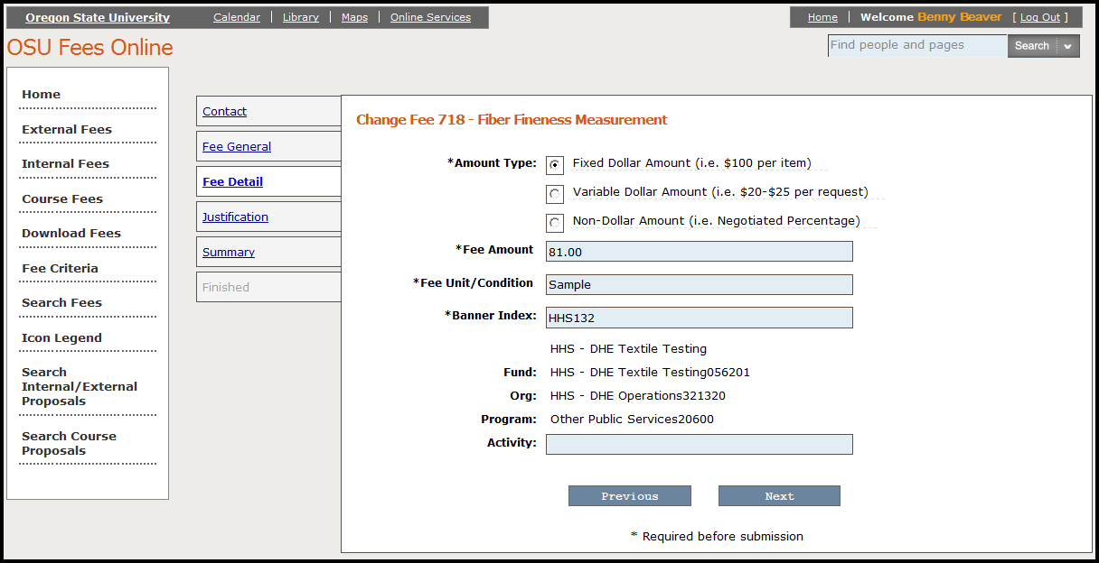

Variable Dollar Amount:

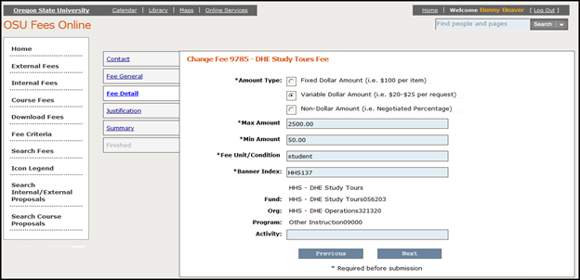

Amount Type
Fixed fees require only the “Fee Amount” field to be completed. Variable fees require both a Max Amount and Min Amount field to be completed. If the amount is a range [$xxx.xx to $xx.xx], specify in the description field on the Fee General page regarding how the amount being charged is determined within that range. Example: 1-5 samples = $ high rate, 6-10 samples = $ rate and 11-20 samples = $ rate.

Note: The amount type of “Non-Dollar Amount (i.e. Negotiated Percentage) is no longer allowed. It is merely listed for the few historical fees which have been grandfathered.

Fee Unit/Condition
This is how the fee will be charged. For example, the charge can be by the hour, sample, or test.

Index
The active Banner Index number for the fee is required and will be validated by the system. This is the index in which the expenses and the revenue for the activity are recorded.

On the Justification screen, enter the reason for the creation, change, or deletion of the fee. Choose from one of the canned justifications or select “Other” to create the specific justification for this fee proposal.

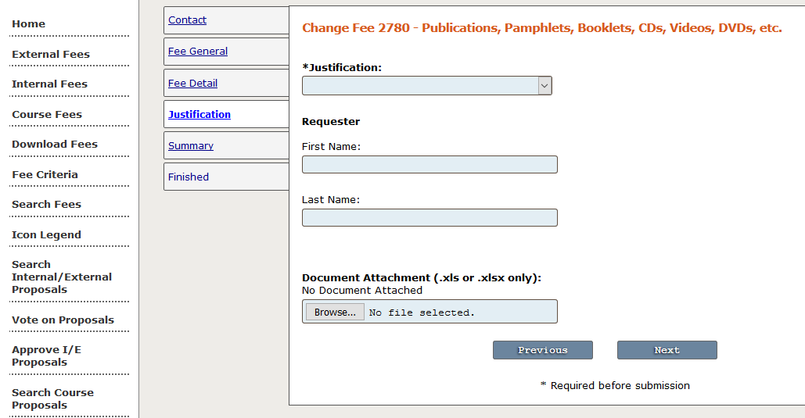

The justification assists the I/E Fee Committee in its’ review process. It does not become part of the fee itself. Do not describe the service here. That should be done in the Description field. The justification answers the “why” question for a change in fee rate or for the establishment of a new fee.

In the requestor section, add the name of the person who requested the fee. Generally, this is not the same person as the person who enters the proposal (also known as the originator). This can be quite useful in the future when questions arrive about a fee calculation or offered service.

The Document Attachment must be a MS Excel worksheet. The most commonly used is the Recharge Fee Calculation Form found in the FIS Policy Manual under Exhibits. This is the document that demonstrates how the fee was calculated. Please be as detailed as possible to answer anticipated committee questions for reasonableness of an expense.

Click Next to continue:

On the summary screen, review the information entered for accuracy:

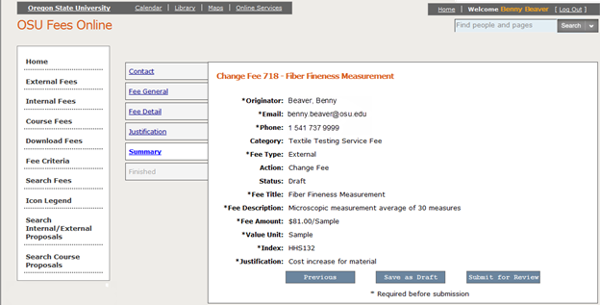

If any of the information is incorrect or you have missed a field, the quick links on the left will take you to specific sections to update. On this page you either “Save as Draft” for further edits or “Submit for Review”. Submit for Review will automatically make the proposal available to the I/E Fee Committee. If the submit button is grayed out, please review all required fields that are denoted with “*”; something is either missing or contains an error.

After submitting your fee for review the next screen will allow you to view the active proposal and/or create a new fee proposal within the same fee category:
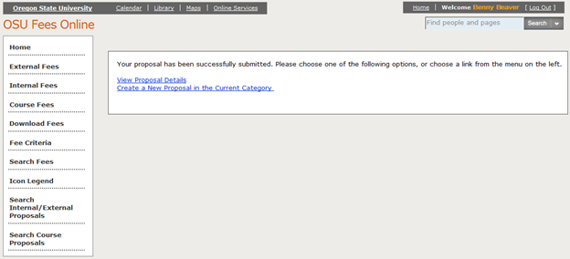

The proposal detail page shows the active proposal and fee detail:

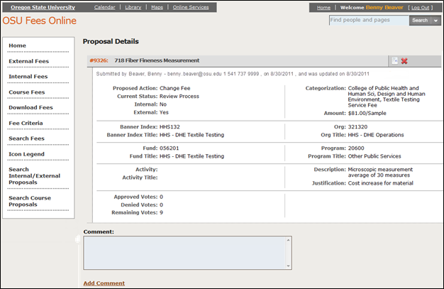

To view the fee history, click the fee detail icon (). To withdrawal the proposal click the icon.

The I/E Fee Committee will review all new fee proposals, and certain change fee proposals based on predetermined criteria. As of the fall of 2021, all fees can be used as soon as approved by the I/E Fee Committee or the Fee Book Administrator. Often though, managers for services where fees have increased will wait until January 1st or July 1st so they can notify their customers of a price increase.

Course Fee Proposal Entry Instructions

Submitting new or revised course fees requires the same login as described above.

To submit a new or revised course fee, select Course Fees from the navigation bar on the left. Select the Subject and applicable Term.

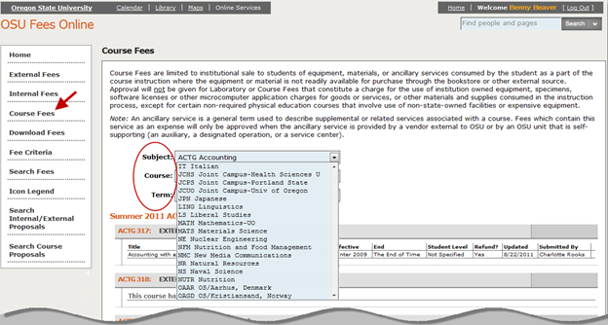

Locate the course where you either want to update a current fee or create a new fee.

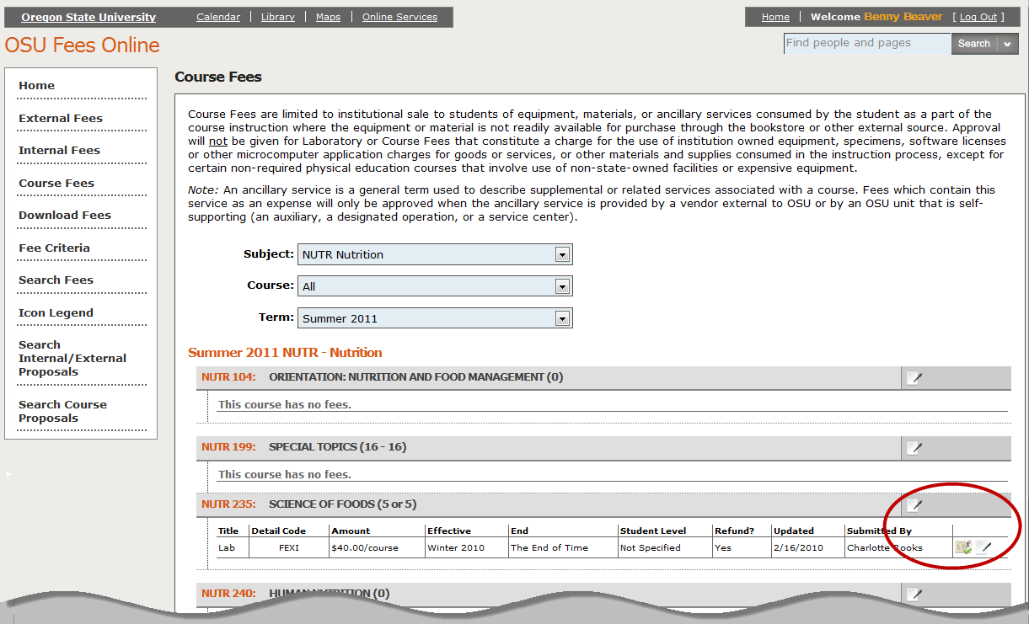

Once you have located the course, you can:
- Mark the current fee as reviewed for the year by clicking the review fee icon ().
- Submit a proposal to create a new fee for this course by clicking the edit icon on the fee title line ( ). You can create the fee from scratch or copy the fee details from an existing proposal.
- Create a new version of the current course fee by clicking on the edit icon which follows the Submitted By name on the course fee line ( ).

The system will take you through a series of steps to submit your fee proposal.

New Version of Current Course Fee
On the Contact screen, verify your information is correct and make any necessary updates. Click Next to continue:

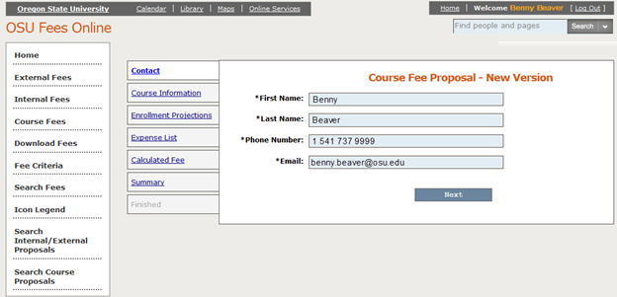

Note: All fields represented by “*” are required before submission.

On the Course Information screen, select the effective term and add the detail code and fee title (if it is a new fee). Click Next to continue:

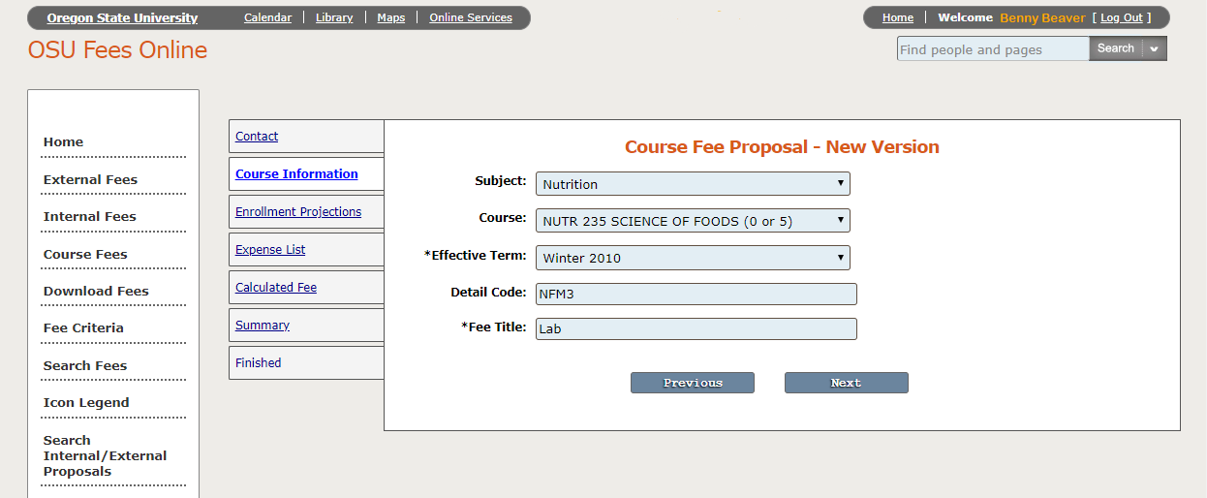

On the Enrollment Projections screen, enter the number of course sections offered each term and the enrollment projections. Click Next to continue:

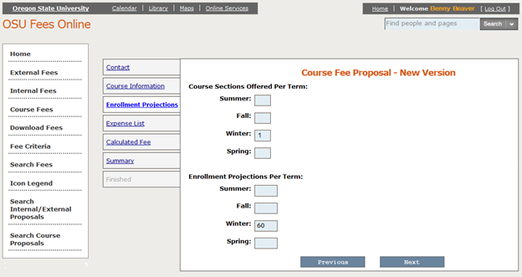

On the Expense List screen, enter the details for all expenses for the course. The expense list will populate at the bottom of the screen. After adding all required expenses, click Next to continue:

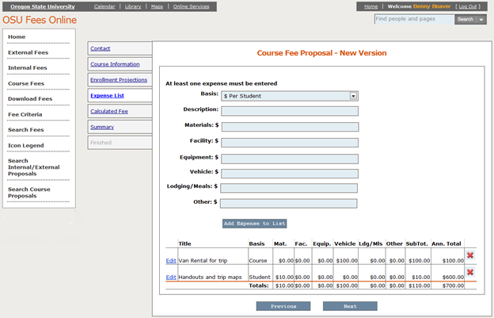

The Calculated Fee screen will display the fee per student based on all of the expenses entered and the enrollment projections. If the fee to be charged is different than the calculated fee, enter the amount here. Also, enter the index for the fee, the activity code (if needed), if the fee is non-refundable, and the justification for the fee. Click Next to continue:

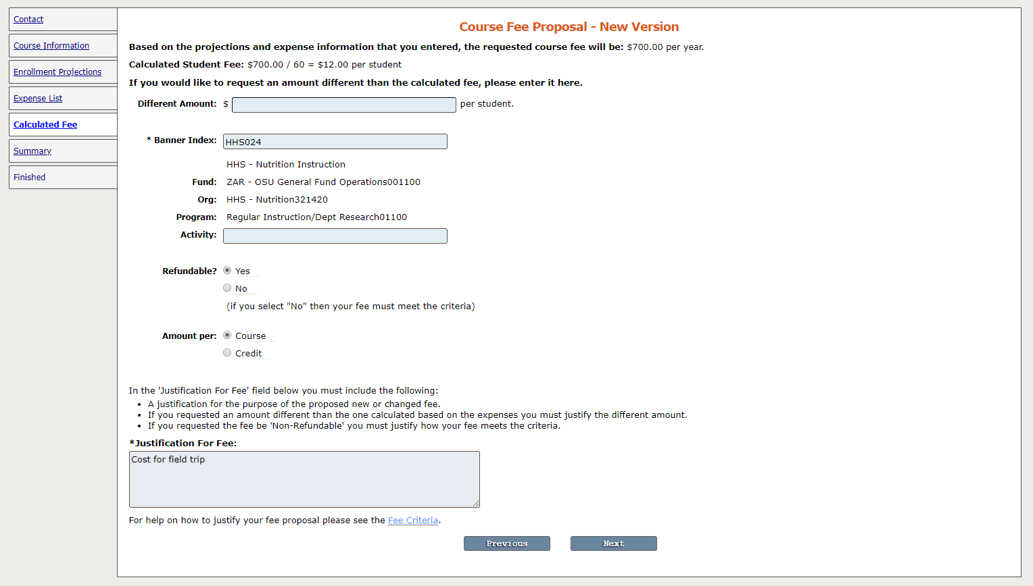

Note: All course fees are refundable unless specifically designated and approved as nonrefundable. Fees may be designated as nonrefundable only if the university would not be able to recover the cost of the fee should the student drop the course before or after the term begins. Examples are materials that cannot be reused or reissued to another student or a field trip discount that has been arranged dependent on the number of participants.

Justification is required for the purpose of the proposed new or changed fee and for any amount different than the one calculated by the system based upon the expenses. The Course Fee Committee requires a detailed expense list and will review fees based upon reasonableness, applicability to policy, and how the fees compare with other similar university courses.

On the summary screen, review the information entered for accuracy. You can return to a previous screen to make any changes necessary, save as a draft, or submit for review.

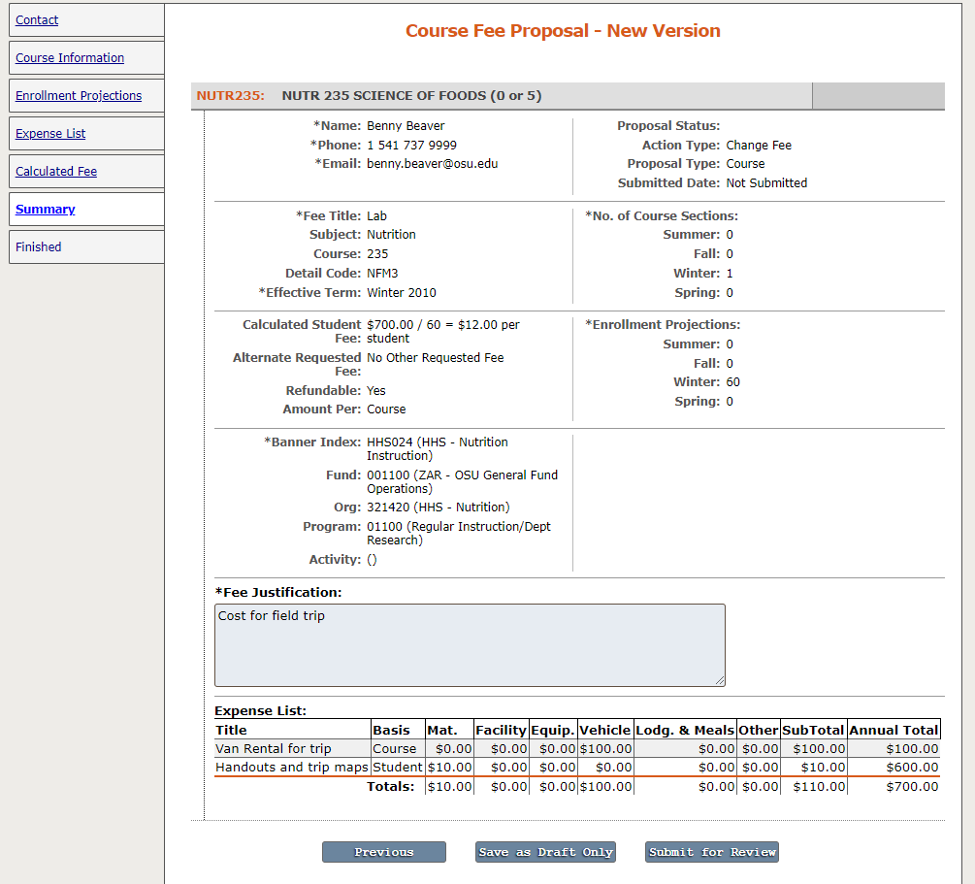

The fee committee reviews course fees for approval. If your fee is approved, you will receive an email of approval with information regarding the next steps in the process (a detail code request and how to contact the schedule desk to have your fee added to the class schedule).

New Fee – Copy from Existing Proposal
To create a new fee for a course, you can copy the fee details from an existing proposal that has been approved or is in review by simply editing as needed instead of creating the fee from scratch.
After clicking on the edit icon on the fee title line ( ), select the subject and course with the fee you would like to copy, select the fee, then click Create a New Fee Proposal From This One:

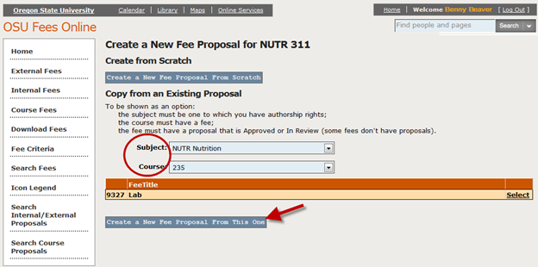

Note: You are only able to copy fees from subjects authorized to your ONID login and courses that have fee proposals that are approved or in review.

Once you have selected the fee to copy, the system will then walk you through the steps for creating the fee proposal as detailed above. Simply edit the details as necessary for the new fee.

Hints, Tips, and How To’s

How to Edit a Proposal in Draft

- Find the link to Search Internal/External Proposals
- Search for your proposal by any of the criteria shown on the screen.
- To view the details, select your proposal from the list by clicking on the view proposal icon () to the left of your name.
- Select the edit icon () to make any changes.

Reports

There are several ways to get a report of fees for a particular unit. Either download the results of a search or Download Fees where you can choose internal, external, or course fees.

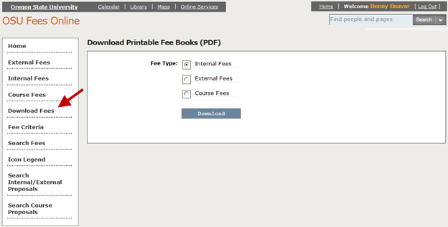

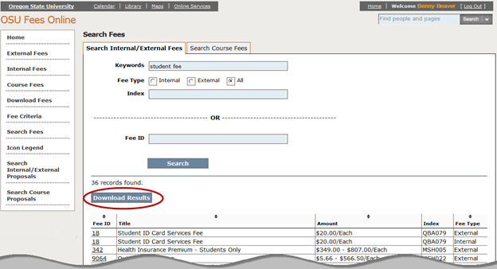

Contact Information:
If you have any questions regarding OSU Fees Online, please contact Charlotte Rooks at 737-5422 or charlotte.rooks@oregonstate.edu or Kayla Campbell at 737-4763 or kayla.campbell@oregonstate.edu.

